**Section 2.7.2**

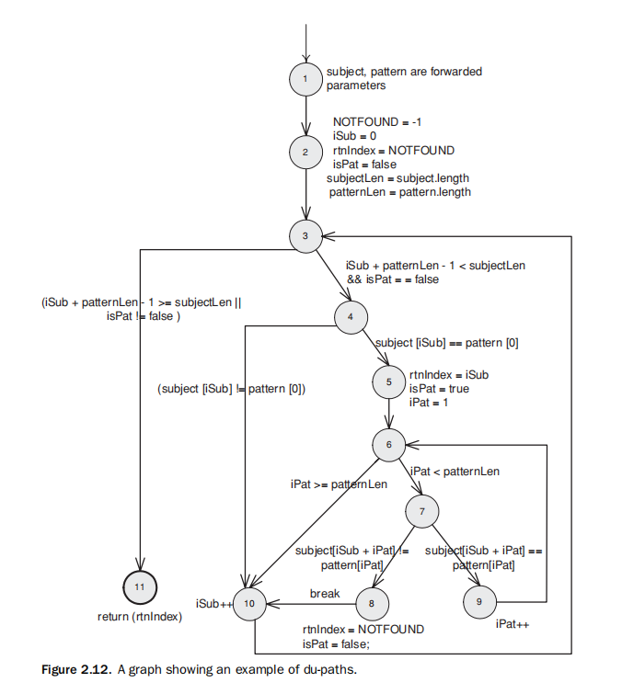

Simplified the original picture：

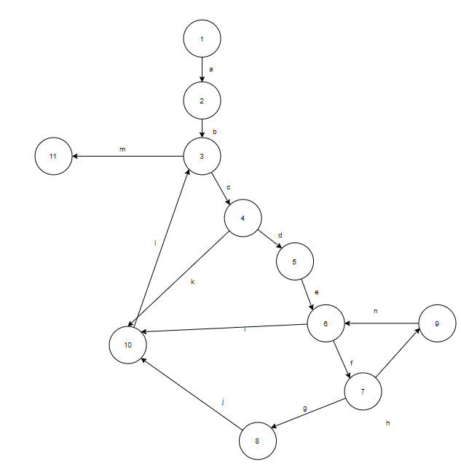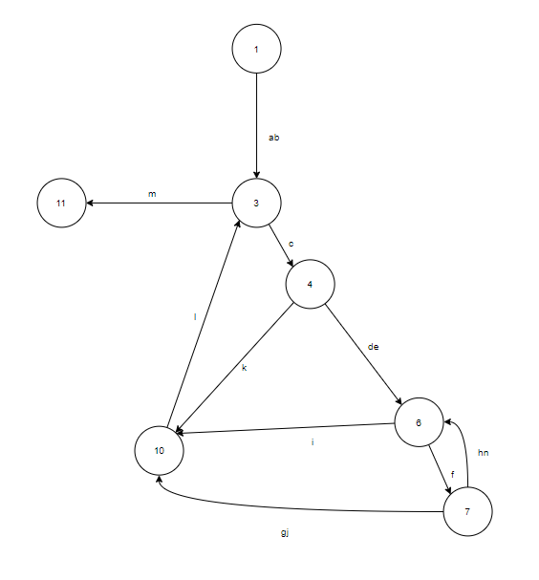

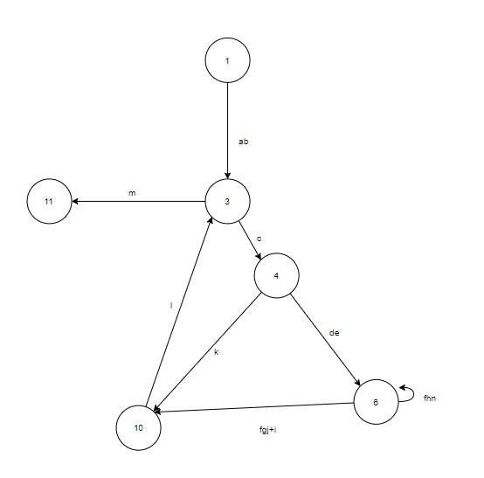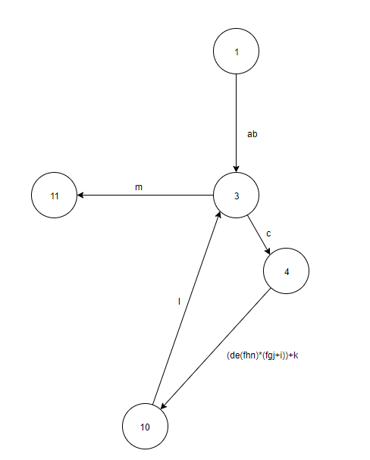

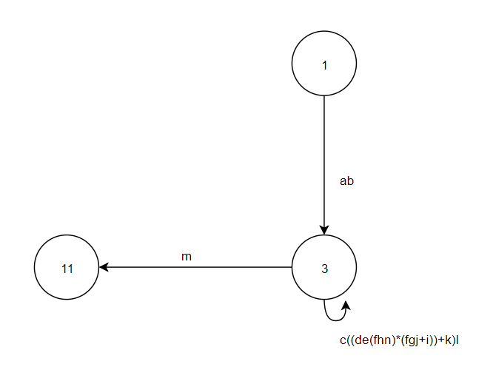

**Expression：**ab[c((de(fhn)*(fgj+i))+k)l]*m

Set weight WA of f to 2.

Maximum number of paths:

1*1[1((1*1((2)^(0-n)*1*1)((2)^(0-n)*1*1+1))+1)*1]*1

=(2)^(0-n) ((2)^(0-n)+1) +1

IF N=2:

=(1+2+4)(1+2+4+1)+1

=7*8+1

=57

Minimum number of paths:

2*3+1=7